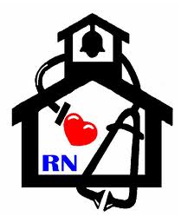
Nurse’s Nook
Pearl Lower Elementary – October
Aly Weems, School Nurse
Tobacco & Sports 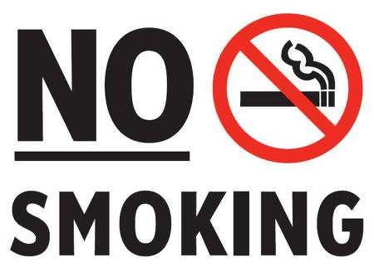
Smoking negatively impacts physical activity- immediately and long-term. In addition to cancer, heart disease and respiratory diseases, smokers have less endurance, reduced physical performance and higher rates of injury.
- Tobacco smoke contains carbon monoxide. This blocks the oxygen from getting to the muscle cells. Smoking also constricts the blood vessels, limiting blood flow to the muscles. Less blood and oxygen flow means that it’s harder to build muscle and muscles tire more easily.
- The decrease in oxygen caused by smoking causes smokers to have higher resting heart rates than nonsmokers, which means their hearts are always working harder pump blood and oxygen to the body. The heart is also not able to efficiently pump the extra nutrients and oxygen rich blood to their muscles during exercise.
- Smoking at any age damages your lungs, but smoking during adolescence also stunts lung growth and can cause lung function to decline years earlier than nonsmokers. As a result, children and teens who smoke are less physically fit and have more breathing problems.
- Smokers suffer from shortness of breath almost 3 times more often than nonsmokers.
- Smoking disrupts bone growth. Smokers have a higher risk of bone fractures, and their broken bones take longer to heal.
- People who quit smoking demonstrate improved exercise performance compared to those who continue to smoke.

- If you or a loved one needs help quitting, you can call 1-800-QUITNOW or 1-800-784-8699! It’s never too late to quit!

